6. Writing SQL queries to filter and sort data from single table.
Create a Table:
CREATE TABLE employees(
id INT PRIMARY KEY,
name VARCHAR(100),
department VARCHAR(50),
age INT,
salary DECIMAL(10,2)
);
select*from employees;
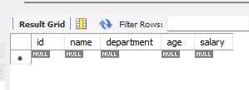

Insert some sample data:
INSERT INTO employees(id, name, department, age, salary)VALUES
(1, 'Pratiksha', 'HR', '25', 50000),
(2, 'Trisharna', 'IT', '22', 60000),
(3, ‘ Khushi', 'Finance','26', 45000),
(4, 'Aniket', 'HR', '31', 55000),
(5, 'Kunal', 'IT', '20', 30000);
select*from employees;
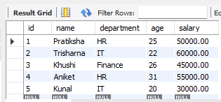
Filter Record Using WHERE
select*FROM employees
WHERE department='IT';

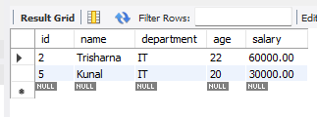
Sort Record Using ORDER BY
SELECT*FROM employees
ORDER BY salary DESC;
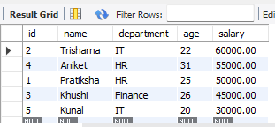
Combine Filtering and Sorting;
SELECT*FROM employees
WHERE age>22
ORDER BY age ASC;
